The Great Forest Protection March
This fall, marchers will leave from the 4 directions of the province to converge on Quebec City on October 11, 2021. It is a great gathering of all the peoples of Quebec to underline the importance of biodiversity. It could mark a major turning point in the economic, ecological and social transition necessary to ensure the health and well-being of present and future generations.
WHY: A hundred protected area projects on public land for southern Quebec have been proposed for years by officials of the Ministry of the Environment and the Fight against Climate Change (MELCC), indigenous communities, citizen groups , RCMs (MRCs), municipalities, community organizations and scientists. These projects to protect important areas of biodiversity have been rejected by the government. These areas would have fulfilled our commitment with the UN to protect ecologically representative and well-connected networks of protected areas and also to recognize the basic needs of indigenous and local communities. Instead, those areas north of the tree line that have been protected have fewer economic advantages, but southern Quebec needs protection too! Every time a species goes extinct, we lose another faithful ally and nature's fragile balance is put at risk. So we put our own health at risk... scientists say, biodiversity is the health of all living things... including humans.
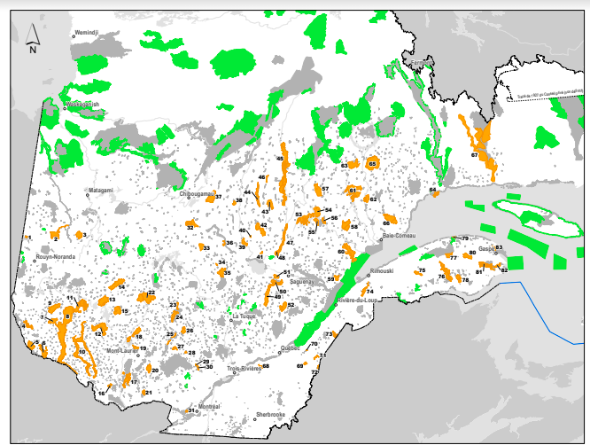
THE PROTECTED AREAS...ONLY IN THE NORTH?
In green you can see what is protected and in orange all of the 83 projects that were discarded, as for now, by the CAQ government .
The call to The Great March ! "The protection of these lands is at the heart of indigenous cultures, Atikamekw, Innu, Wolastoqiyik (Maliseet), Lnu'k (Mi’kmaq), Anishinaabe, and also in the hearts of the many Quebecers who live there deeply connected to the life they provide. Many work tirelessly to protect these lands by thinking of present and future generations, in addition to honouring those who cared for them in the past.” Marie-Andrée Gill
WHO: A central element of the process is to bring together human diversity (native-non-native, woman, man, non-gendered person, racialized person, elder, young person and more). Diversity is an asset everywhere. We honour the indigenous peoples who care for and protect forests, animals, plants and water since time immemorial. Drawing on their past and present experiences and struggles, we all march together for our common future. This March is a chance to get to know each other and to create a culture of empathy * that recognizes the richness of each person, species and people. Today, we ALL become protectors of forests and of future generations. The group that initiated this march is comprised of both Quebecker and Indigenous members.
HOW: - Marchers will leave from different regions of the province towards Quebec City. As of now, we know that a group will leave the Outaouais on September 8th. Another group will leave from the South (Bellechasse) in early October. Others need to be self-organized: for the North: Saguenay-Lac-St-Jean; East: Côte-Nord and Bas du Fleuve-Gaspésie; Eastern Townships; Montreal, etc. You can join the group that will be passing through your region or join us in Quebec for the Passage to Parliament and also for the Great Gathering in a place to be announced.
- Throughout the March, we will take various positive and creative actions to impact, raise awareness and touch the hearts and minds of everyone. All this march takes place in an approach of kindness, connection, curiosity and respect. When we succeed in bringing together a large number of people in a non-violent manner, we are using the strategy which has historically won the greatest struggles and advances for all of earth’s peoples.
- The Great March includes an educational project in schools and a massive citizen mobilization! Children's drawings representing endangered pant and animal species, made in a related educational project, will be given to the marchers. Also, the youth will have the chance to have their environmental concerns heard and taken into account. Their collective demand and their banner of drawings will be hand delivered to the National Assembly.
- Arrival in Quebec: The final destination will host a mass gathering on the last day of the Great March in which all the organizations and citizens wishing to add their voices for the protection of the land can join. Artists, spokespersons (non-native and native) and elected officials will gather to deliver a common message.

Needs and Values:
- Care and Protection of Biodiversity - Universal Health of humanity and all living beings
- Access to nature and interdependent connection
- Deep consideration of the First Nations - Confidence in the human potential of respect and consideration

Demands:
- The protection of 100 priority protected area projects in southern Quebec on public land;
  - The 80 biodiversity reserve projects submitted by the MELCC and the M.R.C., municipalities, community organizations, aboriginal communities, citizens and scientists to the government.
  - Protected area projects initiated by specific indigenous communities
  - Protected area projects led by local communities with strong popular support.

- Support the creation of an independent scientific institution for forest management including indigenous science.
- Support the protection of all urban and ex-urban woodlots at the municipal and provincial level in Quebec. Proposal for the creation of a law facilitating the creation of protected areas in densely populated regions.
Humanity is on the march towards a turning point. We see countless present and emerging initiatives from all walks of life. We invite and encourage the Government of Québec to join this great historic movement to protect and restore our one and only common home: the Earth. This will also require all of us to turn from the present extractive economy to one that is regenerative ** and socially just.

HOW TO PARTICIPATE:
- Join the march from your area and organize a march from your area - register on the webpage or Facebook page!
- Offer the educational project to schools and day camps (can be found on the site www.lagrandemarche.ca)
- Register on the page www.lagrandemarche.ca (under construction) and the Facebook page La Grande Marche
- Raise awareness among politicians in your area - use the descriptive material on our web page
- Prepare creative, educational, connected and heartfelt actions for this fall
- Create connections with the people around you on this issue and share information
- donate on www.lagrandemarche.ca
* The Culture of Empathy promotes the emergence of relationships where Curiosity, Consideration and Connection permeate our intentions, words, actions, interactions and ways of living in all of our relationships.

